**Test Case** **0001**

**System:** VirtuCardsHost & VirtuCardsClient

**Description:** Tests that the user can reset their password

**Severity:** 3

**Instructions**

**Test1**

1. Start VirtuCardHost application
2. Click the button labeled “Sign In”
3. Enter “virtucards01@gmail.com” into the text input labeled “Enter email…”
4. Enter “Testing1” into the text input labeled “Enter password…”
5. Press the button labeled “Login”
6. A window should appear saying “Login Success”
7. Restart the application
8. Click the button labeled “Sign In”
9. After the screen has loaded, click the text labeled “Forgot Password”
10. Enter the email “virtucards01@gmail.com” into the field labeled “Enter email…”
11. Click the button labeled “Send Password Reset Email”
12. After, a popup titled “Reset Email Sent” should appear
13. Click the “OK” button to close the popup
14. Open a web browser and log into the email virtucards01@gmail.com
15. Check the inbox for an email from “noreply@virtucard-4529f.firebaseapp.com”
16. Open the email and click the hyperlink found within
17. A new tab should open with a popup titled “Reset your password”
18. Enter “Testing2” into the popup and press the “Save” button
19. Close the tab where the popup appeared in
20. Go back to the VirtuCardHost application
21. Enter “virtucards01@gmail.com” into the text input labeled “Enter email…”
22. Enter “Testing2” into the text input labeled “Enter password…”
23. Press the button labeled “Login”

**Expected Result:** A window should appear saying “Login Success”

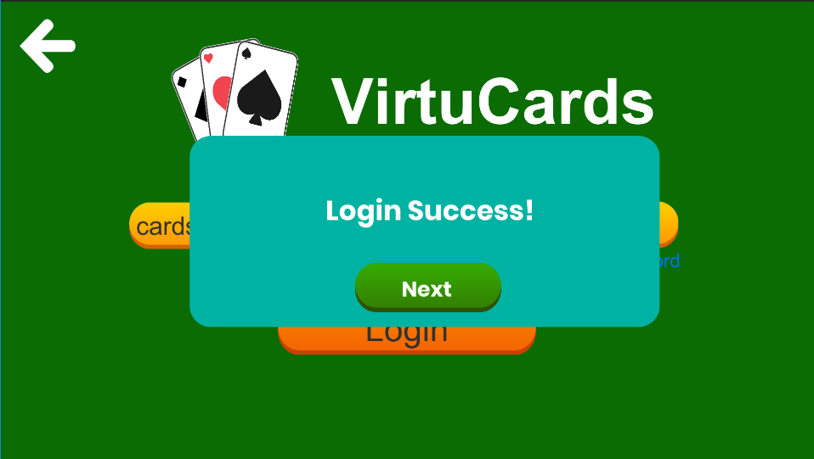

**Test2**

1. Start VirtuCardClient application
2. Click the button labeled “Sign In”
3. Enter “virtucards01@gmail.com” into the text input labeled “Enter email…”
4. Enter “Testing1” into the text input labeled “Enter password…”
5. Press the button labeled “Login”
6. A window should appear saying “Login Success”
7. Restart the application
8. Click the button labeled “Sign In”
9. After the screen has loaded, click the button labeled “Forgot Password”
10. Enter the email “virtucards01@gmail.com” into the field labeled “Enter email”
11. Click the button labeled “Send Password Reset Email”
12. After, a popup titled “Reset Email Sent” should appear
13. Click the “OK” button to close the popup
14. Open a web browser and log into the email virtucards01@gmail.com
15. Check the inbox for an email from “noreply@virtucard-4529f.firebaseapp.com”
16. Open the email and click the hyperlink found within
17. A new tab should open with a popup titled “Reset your password”
18. Enter “Testing2” into the popup and press the “Save” button
19. Close the tab where the popup appeared in
20. Go back to the VirtuCardClient application
21. Enter “virtucards01@gmail.com” into the text input labeled “Enter email…”
22. Enter “Testing2” into the text input labeled “Enter password…”
23. Press the button labeled “Login”

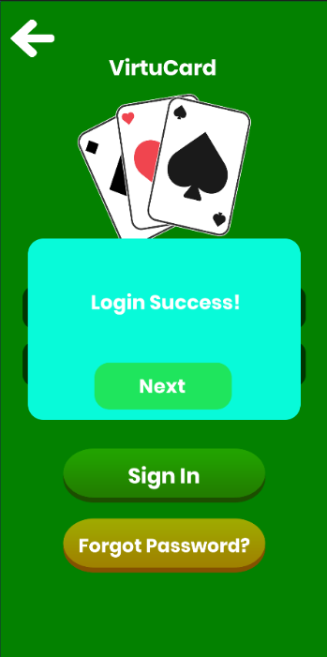**Expected Result:** A window should appear saying “Login Success”

**Test3**

1. Start VirtuCardHost application
2. Click the button labeled “Sign In”
3. Enter “virtucards01@gmail.com” into the text input labeled “Enter email…”
4. Enter “Testing1” into the text input labeled “Enter password…”
5. Press the button labeled “Login”
6. A window should appear saying “Login Success”
7. Restart the application
8. Click the button labeled “Sign In”
9. After the screen has loaded, click the text labeled “Forgot Password”
10. Enter the email “random@gmail.com” into the field labeled “Enter email…”
11. Click the button labeled “Send Password Reset Email”

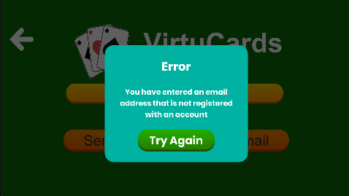**Expected Result:** A window should appear saying “Error”

**Test4**

1. Start VirtuCardClient application
2. Click the button labeled “Sign In”
3. Enter “virtucards01@gmail.com” into the text input labeled “Enter email…”
4. Enter “Testing1” into the text input labeled “Enter password…”
5. Press the button labeled “Login”
6. A window should appear saying “Login Success”
7. Restart the application
8. Click the button labeled “Sign In”
9. After the screen has loaded, click the button labeled “Forgot Password”
10. Enter the email “random@gmail.com” into the field labeled “Enter email”
11. Click the button labeled “Send Password Reset Email”

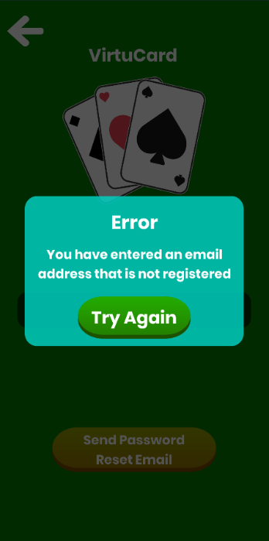**Expected Result:** A window should appear saying “Error”